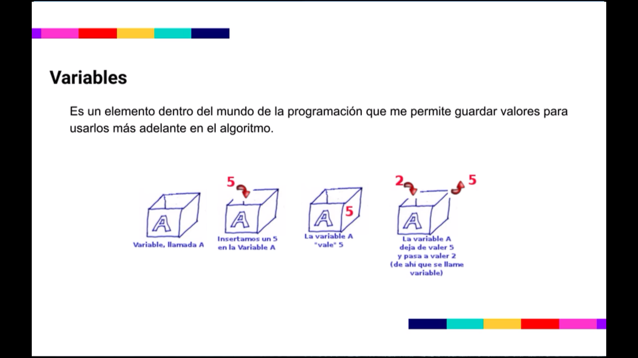

<https://es.wikipedia.org/wiki/Variable_(programaci%C3%B3n)#:~:text=En%20programaci%C3%B3n%2C%20una%20variable%20est%C3%A1,desconocida%2C%20es%20decir%20un%20valor>.

Developer.mozilla

W3schools